Name: **ZOHAIB HASSAN SOOMRO**

RollNo#: **19SW42**

Subject: **DBS**



1. Create 3 different users.

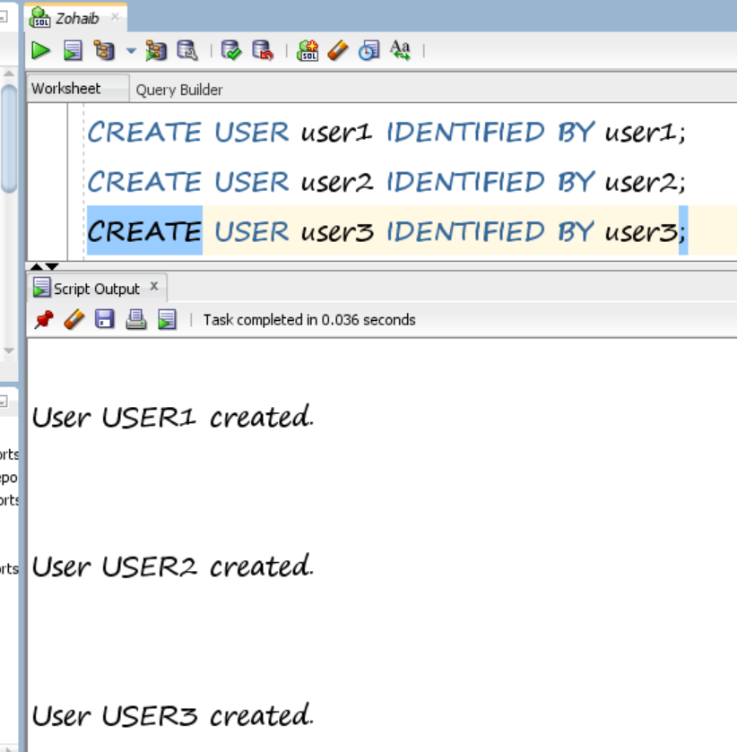

1. Assign different system privileges to any one of the three users.

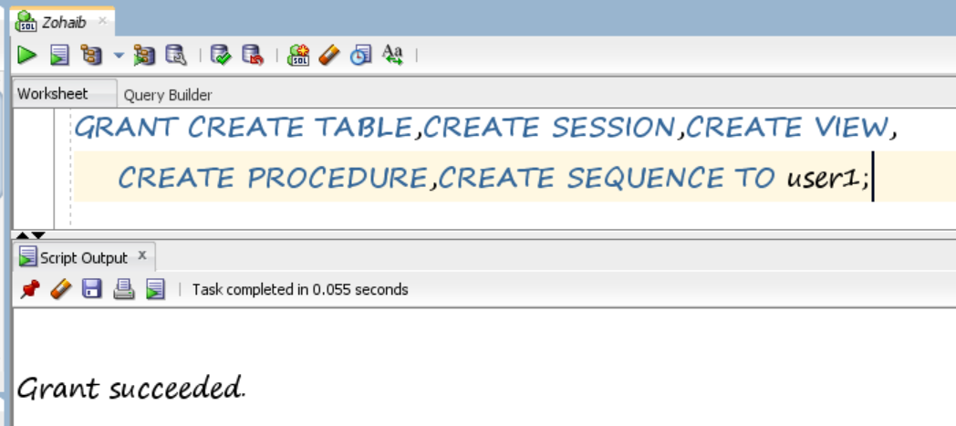

1. Assign different object privileges to any one of the three users.

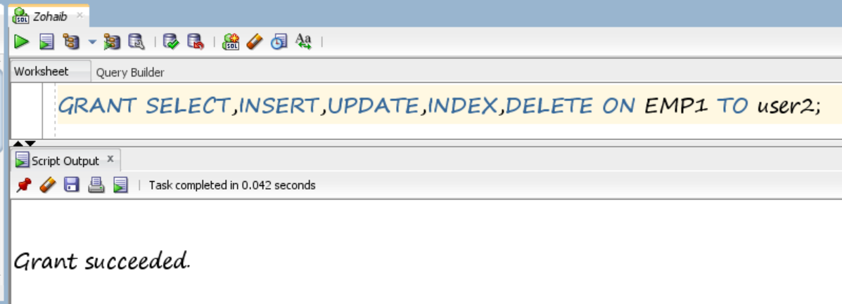

1. Create a role named manager, assign different privileges to that role and then finally assign that role to one of the three users.

**Role Creation:**

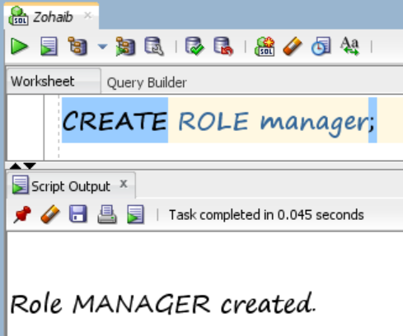

**Assigning Privileges to Role Manager:**

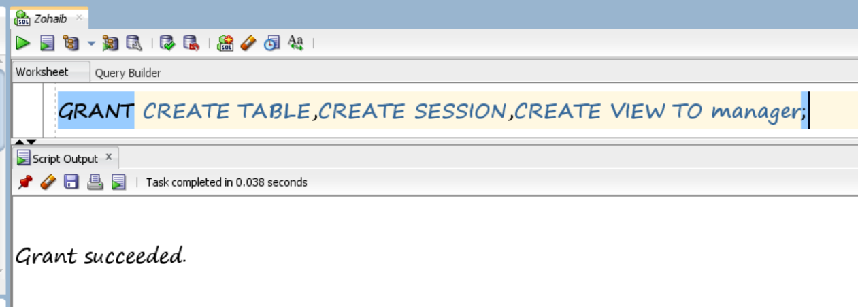

**Assigning Role to user3:**

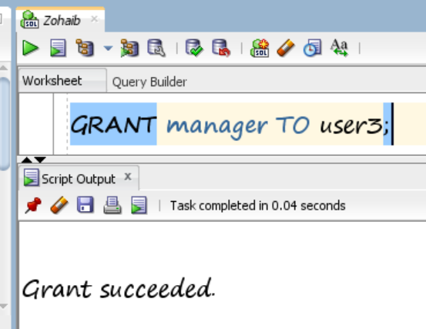

1. Revoke all the privileges from all of the three users.

Revoking From user1:

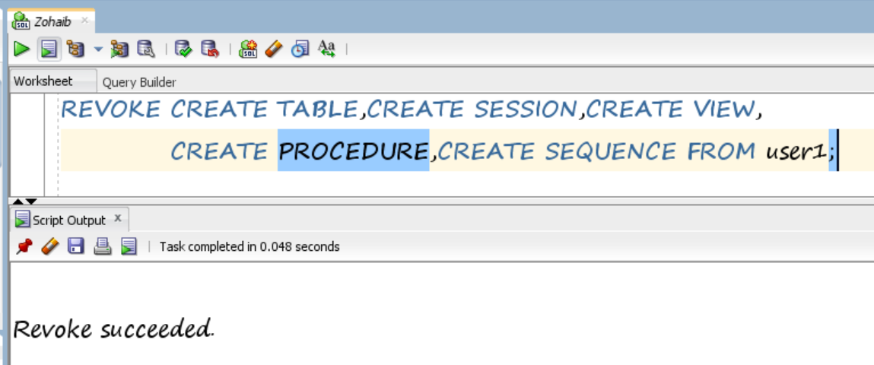

Revoking From user2:

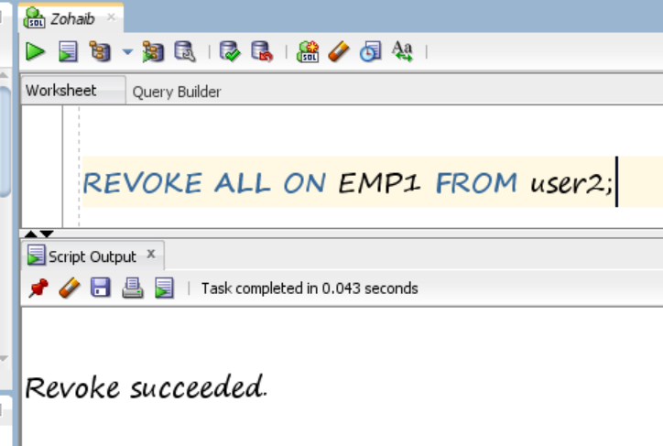

Revoking From user3:

